WELCOME TO
THE
BESS AND MOE GREENBERG FAMILY
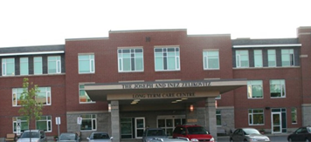
HILLEL LODGE

10 NADOLNY SACHS PRIVATE
OTTAWA, ON K2A 4G7
TEL: 613-728-3900
FAX: 613-728-6550
WEBSITE: www.hillel-ltc.com

Facility

- Residential-style building: Three-story with three elevators - two passenger and one service elevator.

- Underground tunnel connecting to the Community Center

- Wheelchair access to building, resident rooms and all facilities

- Specially designed units for the disabled, grab bars in hallways, other public areas and units

- There are four 25 bed self-contained resident home areas (15 private rooms with 2 piece bath, 4 singles with shared 2 piece bath and 6 2-person basic rooms) with lounge, activity room, dining room; and one 21-bed self-contained resident home area (13 private rooms, with 2 piece bath and 8 2-person basic room). Each room is completely furnished.

- 121 residents. All require some assistance with activities of daily living, and/or suffer some degree of cognitive impairment.

Staffing and Services

- Staff: Administrative; Support; Health Care: Staffing ratio will be determined according to occupancy rates and Ministry of Health and Long-Term Care funding. R.N./R.P.N. staffing complement on all three shifts.

- Language: English.

- Services Include: Meals; Housekeeping; Personal Care; Organized Leisure Activities; Health Services: personal nursing care, medication administration / supervision, therapies, personal or family counseling, 24-hour emergency staff on and off site and physicians.

- Additional Costs: Hairdresser / barber, esthetics, dental care, foot care, vision care, audiologist, cable, internet, phone, newspapers.

Community Facilities

- In-House: Café, Hairdresser / Barber, Synagogue, visitor parking on site.

- Neighborhood: Part of the Jewish Community Centre campus and located in a residential area.

SOME OF OUR OUTSTANDING FEATURES

- Spacious rooms

- Private, semi-private (private room - shared bathroom) or basic (two in a room)

- 24-hour security

- Full linen, laundry and housekeeping services

- Daily activities and entertainment

- Lounges on each unit

- Special Care Unit.

- Home-like kosher meals served by our qualified staff in 5 separate dining rooms

- Registered Nurses/Registered Practical Nurses on staff 24 hours per day

- Special Diets

- Regularly attending physicians

- Therapeutic services

- Café

• Intergenerational Chapel; Synagogue

• Private landscaped garden and patio

• Free parking

• Smoke-free environment

• Sprinkler system throughout

• Wheelchair access throughout

• Nurse call system

• Secure door call system

Resident Rates

Residents are charged on a monthly basis and are billed once per month. The rate is set by the Province of Ontario and is the same for all Long-Term Care Facilities. The current rates in effect are:

(Daily) (Monthly)

Basic - $62.18 $1891.31
Semi-Private - $74.96 $2280.04
Private - $88.82 $2701.61

Residents who qualify for a rate reduction due to income level or exceptional circumstances may pay a rate less than the Basic daily rate.

Eligibility for subsidized care is determined by verification of the applicants’ income level for the preceding year. To apply for a rate reduction or to maintain eligibility the applicant or his/her representative must complete the Ministry of Health “Application for Long-Term Care Home Accommodation Fees”. Further information is available from the Social Work Department.

How to Apply:

• Admission/Discharge: Process determined by the Local Health Integration Network (LHIN) formerly known as the Community Care Access Center (CCAC). Facility designated 3a + 3b (priority status given to Jewish applicants). Please call 613-745-5525 for more information.

Inquiries

Linda Yeung, Registered Social Service Worker, 613-728-3900 ext. 790, email – linda@hillel-ltc.com.

ROOM LAYOUTS

Each room features a shared wheelchair accessible 2-piece bathroom, complete with vanity and toiletry cabinet.
Includes: all meals, housekeeping, personal care, organized leisure activities and health services.

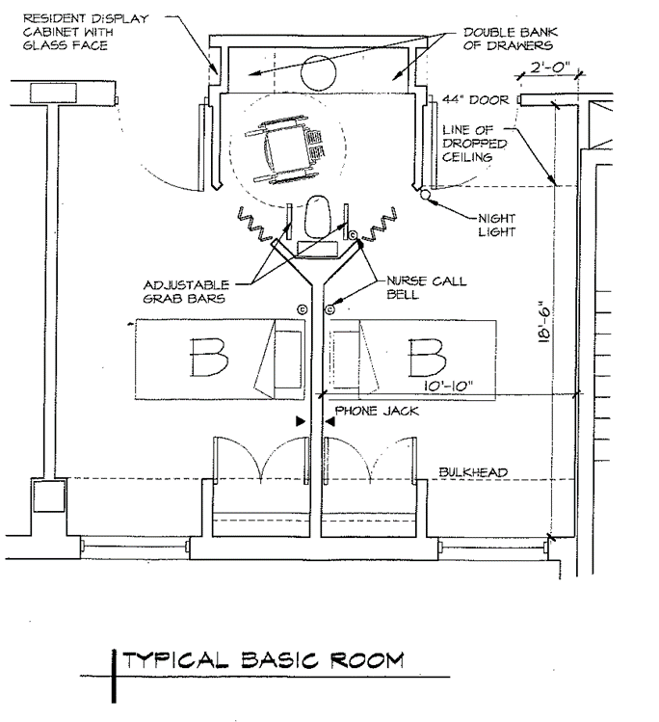

One room shared by two residents
320 sq. ft. (Approx.)

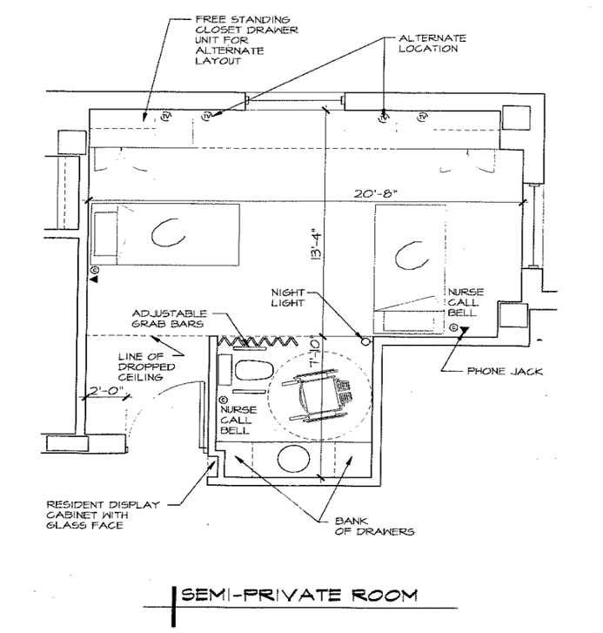

Two resident rooms joined by a shared washroom
175 sq. ft. (Approx.)

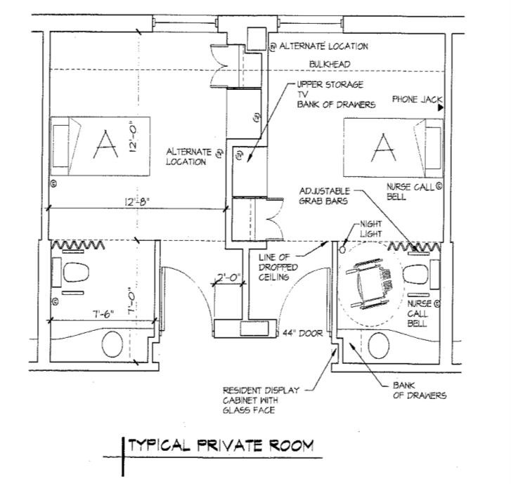
CHEST OF DRAWERS

Image depicts two private rooms
185 sq. ft. (Approx.)

